
FACULTY OF SCIENCE

DEPARTMENT OF SPACE SCIENCE AND APPLIED PHYSICS

Tomato disease detection using computer vision
By
Nyasha Masendeke R2110395

A thesis submitted in partial fulfillment of the requirements of the degree of BSc Honours Industrial Physics (HIPH)

Supervisor: Professor E. Mashonjowa

DECLARATION
I, Nyasha Masendeke, declare that the contents of this thesis represent my own unaided work, and that the thesis has not previously been submitted for academic examination towards any qualification. Furthermore, it represents my own opinions and not necessarily those of the University of Zimbabwe

________________________________________________________ [Supervisor’s Name] Date: ___________________________

APPROVAL FORM

I/We hereby certify that I/we have read this thesis prepared under my/our direction by [Enter Student Name – remove brackets and italics after entering information], titled [Enter Thesis Title] and recommend that it be accepted as fulfilling the dissertation requirements for the degree of BSc Honours [Insert Degree programme] ([Insert programme code]).

_______________________________ Date: ____________
[Insert supervisor’s name]

_______________________________ Date: ____________
[Insert co-supervisor’s name]

_______________________________ Date: ____________
[Insert co-supervisor’s name]

DEDICATION
THIS SECTION IS OPTIONAL. Perhaps you would like to dedicate your document to your parents, grandparents, or other influential figures in your life. This is the place that you would write out your dedication.

ABSTRACT
This project is about diseases which affect tomatoes and how recent developments in technology can aid farmers in fighting these diseases. Tomato plants in Zimbabwe and overall globe provide rich nutrients to consumers such as potassium, nitrogen and calcium. The farming of these plants can be done in greenhouse and outdoor from small, medium and large-scale production. The diseases which affect the crop is late blight and early blight. Conditions under which these diseases thrive include warm-to-cool, wet, and humid conditions. Farmers usually use periodic visual inspection for certain days. Carrying out these inspection procedures can take time for large scale farmers, while for small to medium farmers in can be noticed during set inspection periods. The complementing of the visual inspection methods with computer vision using cameras and embedded devices can provide advantages and better disease control measures. For these technologies to enable farmers to reduce tomato loss due to mentioned diseases, data must be available. In this project part of the data was collected from Internet platforms such as Kaggle. This data must be processed for use by computer vision models for disease detection. Embedded devices by themselves cannot run state of the art models for different task without optimising for hardware performance. Hence certain techniques are used to improve hardware and algorithmic performance for disease detection. Transfer learning is used in this project for detection, by using a better model in conjunction with a smaller model. Confidence scores a produced by the small model of the presence of disease based on images from plant leaves. This can aid famers to better reduce tomato disease damage and loss when deployed on site as alerts can be provided to farmers.

ACKNOWLEDGEMENTS
Perhaps you wish to acknowledge your supervisors and other members of staff or some of the fellow students that helped you work on your thesis/dissertation. Here is the page where you would do that.
Include name of person, with brief explanation if necessary. You can thank as many people as you wish (but within reason).
If you have received funding from any institution, make sure you write the acknowledgement statement according to their instruction

TABLE OF CONTENTS
DECLARATION i
APPROVAL FORM ii
DEDICATION iii
ABSTRACT iv
ACKNOWLEDGEMENTS v
TABLE OF CONTENTS vi
LIST OF TABLES x
LIST OF FIGURES xi
CHAPTER 1: BACKGROUND AND JUSTIFICATION 1
1.1. Introduction 1
1.2.Problem Statement 1
1.3 Aims and Objectives 1
1.4. Research Questions…………………………………………………………………………………..1
1.5. Justification And Conclusion………………………………………………………………………………...2
CHAPTER 2: LITERATURE REVIEW 2
2.1. Introduction 2
2.1.2. Tomato Diagnosis Background 2
2.1.3. Computer Vision Models and Deep Learning 2
2.1.4 Related Implementation…………………………………..3
2.2 Model Architectures For Edge Devices………………………………………...4
2.3. Embedded Hardware Boards…………………………………………………..5
2.4. Conclusion...………………………………………………………………….11
CHAPTER 3: MATERIALS AND METHODS 3
3.1. Subsection 1 (heading level 2) 3
3.1.1. Subsection (heading level 3) 3
3.1.1.1. Subsection (heading level 4) 3
CHAPTER 4:RESULTS AND DISCUSSION 3
3.1. Subsection 1 (heading level 2) 4
3.1.1. subsection (heading level 3) 4
3.1.1.1. subsection (heading level 4) 4
CHAPTER 5: SUMMARY,CONCLUSIONS AND RECOMMENDATIONS 4
3.1. Subsection 1 (heading level 2) 5
3.1.1. subsection (heading level 3) 5
3.1.1.1. subsection (heading level 4) 5
APPENDICES 5
REFERENCES 7

LIST OF TABLES

Table 1.4.1 Project requirements and cost 2

Table 1.4.1 Project timeline 3

LIST OF FIGURES

Figure 1:Showing Mobile Net Series 7
Figure 2 : Showing YOLO Series 8
Figure 3 :showing Efficient Net Series 9
Figure 4: showing NVIDIA Jetson Series 10
Figure 5: showing Raspberry Pi 5 11
Figure 6: showing Arduino Nicla Vision 11
Figure 7: showing STM32N6 Microcontroller 11

CHAPTER 1: BACKGROUND AND JUSTIFICATION
  - Introduction
Diseased plants cause losses for farmers in revenue and in crop output. Late and early blight are some of the diseases which affect tomato plants. Early blight causes dark, brown spots with concentric rings on lower leaves, appearing early in the season. Late blight causes rapidly spreading, watery, olive-green to brown lesions on all parts of the plant, often with white mold underneath. Mitigation of diseases before spreading and before major damage is required to prevent plant loss. Computer vision is the processing of visual input to recognize objects, detect patterns, and track movement using techniques like deep learning. Visual features of tomato leaves can be used by computer vision models to detect early and late blight. This project is a solution to disease detection using convolutional neural networks on embedded systems. The gap being filled with this research is the use of computer vision models on site with a camera taking images for disease classification with prediction being output in real time providing farmers with insights of potential plant losses. These diseases were selected for this research due to availability of annotated image data for use in computer vision models. State of the art computer vision is usually done on GPU (graphics processing unit) therefore training on non-specialized hardware is a gap to be filled in terms of tomato farming. The training of the vision algorithm on embedded devices is carried out, noting potential limitations and advantages of the hardware mentioned.

  - Problem Statement
The late detection of tomato diseases leads to low yields and in general low profits for farmers. Detection of tomato diseases in later stages increases treatment costs due to more extensive and aggressive management strategies. Rapid disease spread is also a factor to consider as it makes containment efforts harder and costlier.
  - Aim And Objectives
1.To create a model for early tomato disease detection.
2.To review the computational constraints of training and inference on edge devices.
3.To devise embedded hardware improvements for edge devices.

Research Questions
1.How can computer vision models for tomato disease detection be trained and run on embedded hardware.
2.What are the constraints of training and inference of deep learning models on embedded hardware.

  - Funding/Budget
Table 1.4.1 Project requirements and cost
Component | Cost
Raspberry Pi (4 or 5) | 90
Camera module | 8
DC power supply (5V/12V) | 4.50
Transport costs | 10
Total | 114.5

  - Project Timeline
Table 1.5.1 Project timeline
Project task | Project months
 | Nov | Dec | Jan | Feb | Mar | Apr | May
Research proposal | X | X
Dataset preprocessing |  |  | X | X
Model selection |  |  |  | X
Model fine tuning/training |  |  |  |  | X | X | X
Model evaluation and validation |  |  |  |  |  | X | X
TensorFlow lite ‘model conversion |  |  |  |  |  |  | X
Deploy binary on microcontroller |  |  |  |  |  |  | X
Control environment setup |  |  |  |  |  | X
Embedded hardware inference evaluation |  |  |  |  |  |  | X
Documentation and thesis write-up | X | X | X | X | X | X | X

  - Justification and Conclusion
Farming is one of the major economic activities in Zimbabwe and innovative solutions that allow for better produce are necessary. Hence classification of crop diseases is a milestone for reducing losses and enabling farmers with current technological advancements in agriculture.
Machine learning models which are run on edge devices allow end users to reduce latencies, real time detection of diseases and end users have control over their data. The use of these models on embedded systems also requires monitoring of any constraints which need improvement both in terms of hardware and software.
This study advances prior work in three key respects. First, unlike most published implementations that train on a workstation and deploy only inference to an edge device, this project evaluates MobileNetV3Small training directly on the Raspberry Pi 5, providing empirical data on the hardware constraints of on-device learning in a resource-limited agricultural context. Second, the integration of Grad-CAM spatial explanations with the inference pipeline allows farmers to identify which leaf regions drove a prediction, improving interpretability beyond classification-only outputs. Third, the inclusion of Population Stability Index (PSI) monitoring addresses a deployment reliability gap: models trained on laboratory datasets can degrade silently when exposed to field images over time, and this system provides a mechanism to detect and flag that distribution shift at inference time.

CHAPTER 2: LITERATURE REVIEW
2.1 Introduction
Human vision is versatile when it comes to classifying images of diseased tomato plants with enough disease prior knowledge on a single plant at once. The only drawback comes when inspecting and classifying tomato plants on medium to large scale tomato farms at once. Inspection on large scale would be tedious and require more people for plant inspection. Hence the use of cameras with dedicated computers for processing images of plants captured at once on large and medium scale saves time and human labor. Utilizing cameras, computer hardware and computer vision algorithms provides farmers with insights of crop health at once from small, medium and large-scale farmers. Computer vision algorithms and their variant architectures can be deployed on the computers in conjunction with cameras for real time plant inspection and disease inspection. State of the art methodologies in utilizing computer vision models require high performing GPUs for training which is challenging for most farmers to get access to in developing countries such as Zimbabwe. Hence the use of embedded hardware which is cheap and readily available for training and inference is an advantage for farmers to detect diseases on site. This literature review analyses the broad subject of computer vision and embedded hardware training for integration in farms.
2.1.2 Tomato disease diagnosis background
Traditional farming practices in the diagnosis of plant diseases use visual inspection methods. People manually categories different diseases and recommend the necessary chemicals to eradicate the disease.The identification of tomato plant disease starts from visual inspection to note the differences such as brown or black patches and holes on the plant and then to look for the insects also(Agarwal, et al). These methods are carried out once a certain number of days which can be too late for disease intervention These methods are carried out once a certain number of days which can be too late for disease intervention According to (Crop serve, 2023) late blight and early blight are one of the diseases affecting plants in Zimbabwe. Early blight and late blight are serious fungal-like diseases affecting tomatoes and potatoes. Early blight (Alternaria solani) causes dark, concentric "target" spots on older leaves and thrives in warm, humid weather. Late blight (Phytophthora infestans) causes rapid, water-soaked, greasy-black lesions in cool, wet conditions, often destroying entire plants.

2.1.3 Computer Vision models and deep learning
Machine learning on embedded devices which are resource constrained can aid farmers in tackling the diseases mentioned above. These models alleviate the problem of late detection as they function in real time on site with or without schedule. Machine learning includes several branches which can be divided into computer vision, natural language processing and speech recognition. Computer vision models use neural networks to learn increasingly abstract representations of data. Convolutional Neural Networks (CNNs) are computer vision algorithms specifically designed for processing grid-like data, such as images(Akintola K.G et al., 2025).These networks are implemented with hierarchical functional blocks which apply filtering, non-linearity activation functions, down sampling, flattening of the input vector into 1D block for the feed forward networks. Neural networks derived from biology as analogy of the connectionist of the human brain comprise the field of deep learning. Deep learning evolved with many models for the classification of images, such as Convolutional Neural Network (CNN) (Wan L et al.,2013), LeNet (LeCun et al., 2015), Alex Net (Krizhevsky, Sutskever, and Hinton., 2012), VGG Net (Simonyan and Zisserman, 2014), etc. All these models essentially exploit directly raw data without using the hand-crafted features (Al Hiary et al.,2011; Mokhtar et al., 2015). Features are the details for the problem to be solved such as in facial recognition they are edges, nose and eyes etc. To produce the final algorithm requires specific hardware dedicated to tensor, vector and matrix processing. Graphics processing units are the main hardware used in making of the state-of-the-art models for computer vision. Computer hardware such as GPUs are highly parallel in their design architecture enabling them to simultaneously solve a problem by divide and conquer utilising many processors. The limited availability of these GPUs for small and medium farmers whose agricultural practices are to be data driven is a major challenge.
Hence the use of pretrained models in conjunction with embedded hardware can alleviate the costs and need for specialised hardware. These large models which are trained on a vast corpus of data are then specialised for a specific task using certain methods such as transfer learning. One of the best models for edge inference is mobile net with specific architectural design tailored to embedded devices. For the specific task of embedded detection transfer learning is an optimal option as it derives learned capabilities from better models for the diseases to be detected. Transfer learning allows the use of fewer data in training a neural network compared to training from scratch that requires large amounts of data (Mkonyi et al., 2020). Transfer learning leverages knowledge learned from pre-training on a large-scale dataset, such as ImageNet, and applies it to a target task with limited labelled data (Zehui Zhao et al., 2024).
2.1.4 Related implementation
Previous implementation include (Xiang et al., 2019) used transfer learning in fruit classification using MobilenetV2.The MobileNetV2 was used as a base network while the top layer of the base network was replaced with SoftMax classifier and a convolution layer. To prevent overfitting dropout was used and Adam optimizer was utilised in the adjustment of the learning rate.

2.2 Model series architectures and Embedded systems review
For this section, the researcher looks at the available embedded hardware available in Zimbabwe and the potential open-source models for disease classification. The researcher is giving some of the most important specifications which led to the decision making of which models and embedded hardware the researcher is going to use for the building of the system.

2.2.1 Computer vision model (Mobile net Family)
This model is built on depth wise separable filters as the core layers.
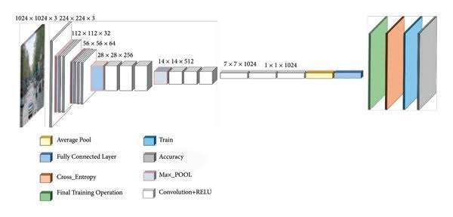
Figure 2.1: Mobile Net Series

- Primary Tasks: Image classification, object detection (SSD Lite), and semantic segmentation.
- Performance: Achieves high accuracy on ImageNet (e.g., 70.8% with original V1) with low latency.
- Model Size: Very small memory footprint (e.g., ~18 MB for certain V1 versions).
- Inference Engine: Optimized for TensorFlow Lite, Core ML, and other edge AI frameworks.
- Depth wise Separable Convolutions: Instead of standard convolutions, Mobile Net breaks convolution into a depth wise convolution spatial filtering and a pointwise convolution (feature combination).
- Hyperparameters for Scaling: The models use width and resolution multipliers to trade-off between accuracy and latency, allowing developers to scale the model size based on device constraints.

YOLO Series

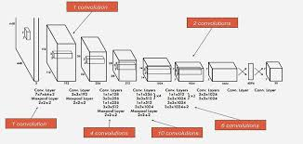
Figure 2.2: YOLO Series

- Model Type: Single-shot, Convolutional Neural Network (CNN) based object detector.
- Primary Tasks: Real-time object detection, image segmentation, pose estimation, tracking, and classification.
- Performance: High precision/recall trade-off; capable of >100 FPS on GPUs, with specialized versions (v8/v10) designed for edge device deployment.
- Input: Single colour image (usually resized to 640x640 or higher).
- Output: Multiple bounding boxes (x, y, w, h), abjectness scores, and class probabilities.
- Loss Function: A combination of localization loss (IoU), confidence loss, and classification loss.
- Supported Frameworks: PyTorch, ONNX, TensorRT, TFLite

Efficient Net Series

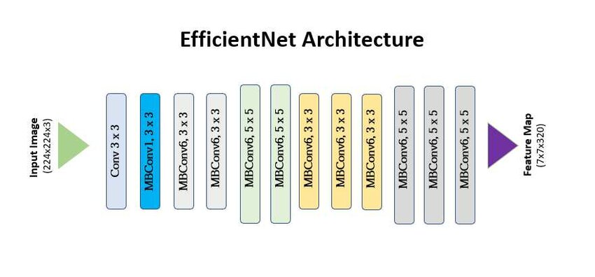
Figure 2.3: Efficient Net Series

- Compound Scaling: Rather than scaling only one dimension (e.g., deeper, not wider), Efficient Net balances network width, depth, and resolution using a fixed set of scaling coefficients.
- Base Model (B0): The baseline architecture, EfficientNet-B0, was developed using Neural Architecture Search (NAS) to balance accuracy and latency.
- MBConv Blocks: The architecture is built upon Mobile Inverted Bottleneck Convolution (MBConv) blocks, similar to MobileNetV2, which are computationally cheap.
- Squeeze-and-Excitation (SE): Every block includes SE modules that adjust channel-wise feature strengths.
- Activation Function: Uses Swish activation functions for improved performance.

2.2.2 Embedded Hardware
NVIDIA jetson series
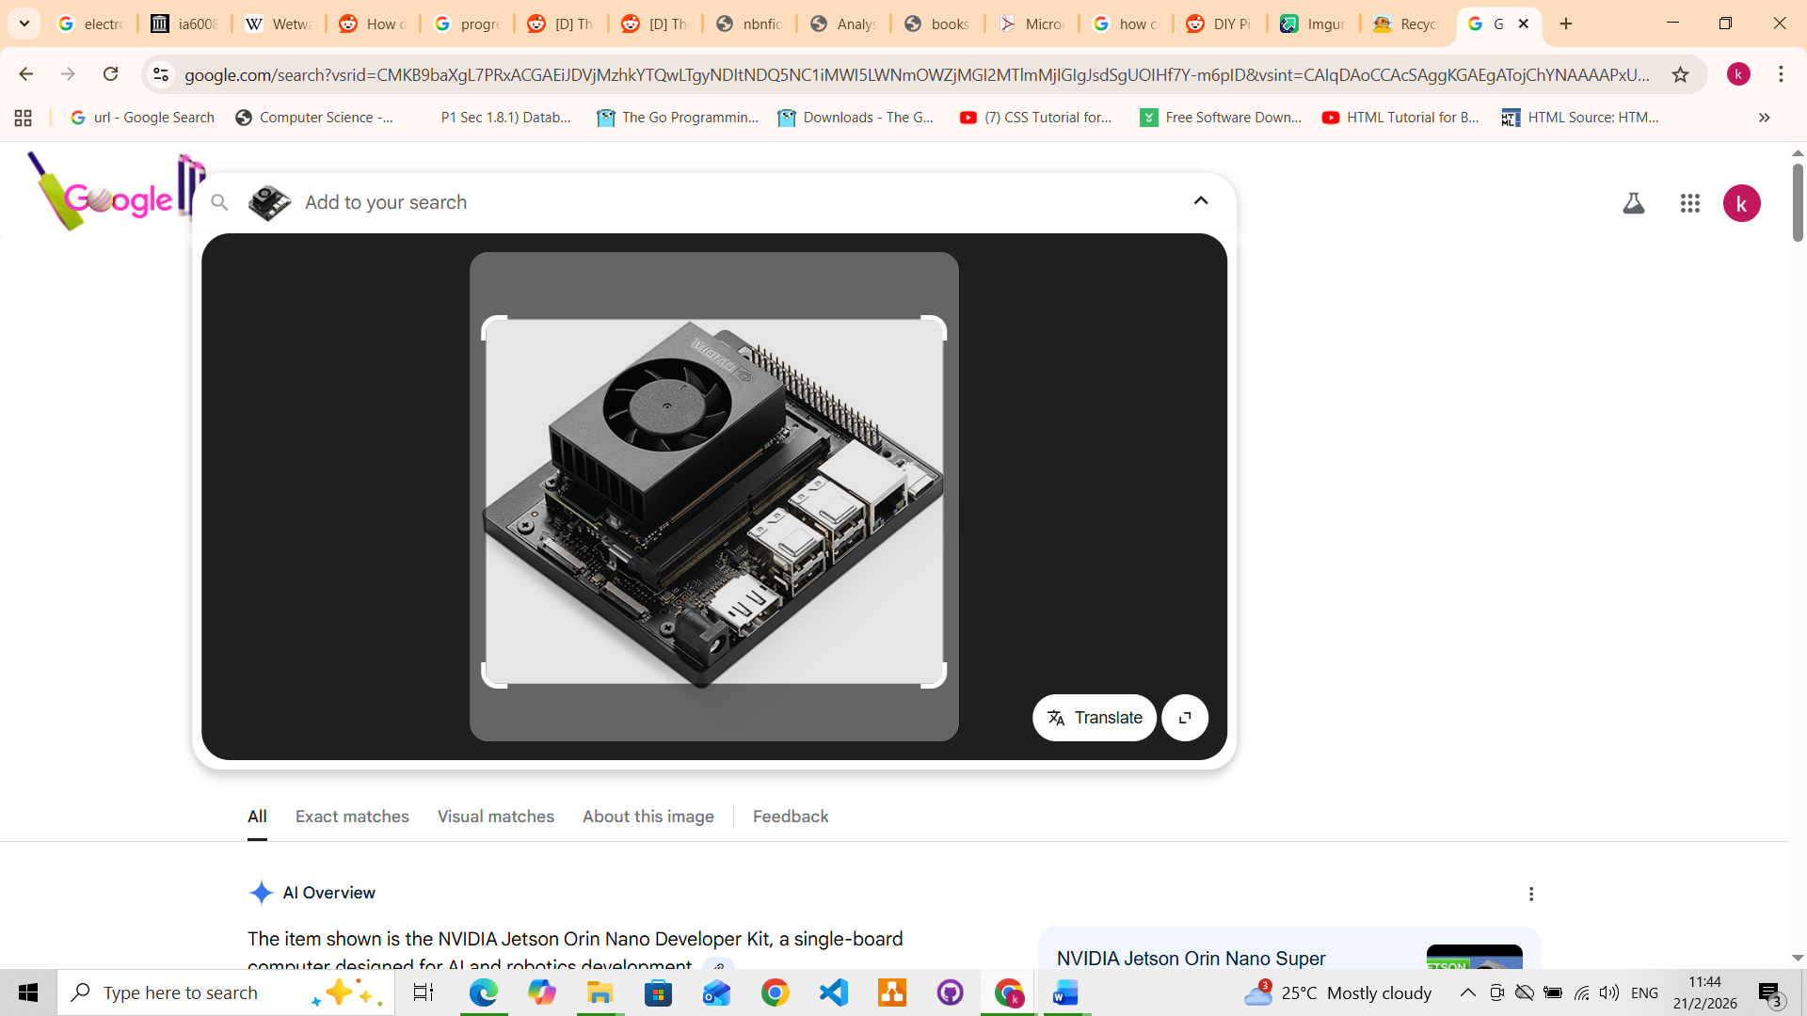
Figure 2.4: NVIDIA Jetson series

- GPU: 128-core Maxwell architecture.
- CPU: Quad-core ARM® Cortex®-A57 MPCore.
- Memory: 4 GB 64-bit LPDDR4.
- Storage: 16 GB eMMC 5.1 or microSD card.
- Price: 950

Raspberry Pi 4/5

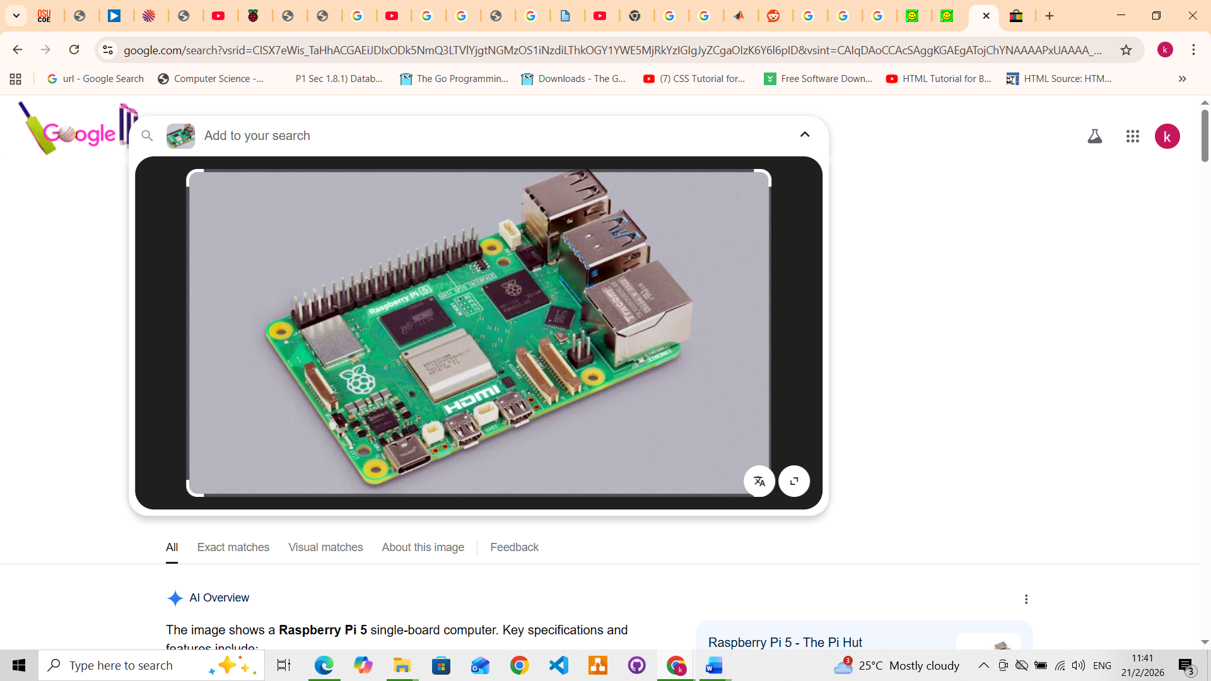
Figure 2.5: Raspberry Pi 5

- Processor: Broadcom BCM2712 2.4GHz quad-core 64-bit Arm Cortex-A76.
- RAM: 4GB or 8GB LPDDR4X-4267 SDRAM.
- GPU: Video Core VII, supporting OpenGL ES 3.1, Vulkan 1.2.
- Storage/Ports: MicroSD slot (high-speed mode), 2x USB 3.0 (5Gbps), 2x USB 2.0.
- Networking: Gigabit Ethernet (supports PoE+ with HAT), Dual-band 802.11ac Wi-Fi, Bluetooth 5.0/BLE.
- Display: Dual 4Kp60 HDMI with HDR.
- Expansion: 40-pin GPIO header, 1x PCIe 2.0 x1 interface.
- Power: 5V/5A DC via USB-C (supports power delivery).
- Features: Real-time clock (RTC), dedicated fan header, and power button.
- Price: 150

Arduino Nicla Vision
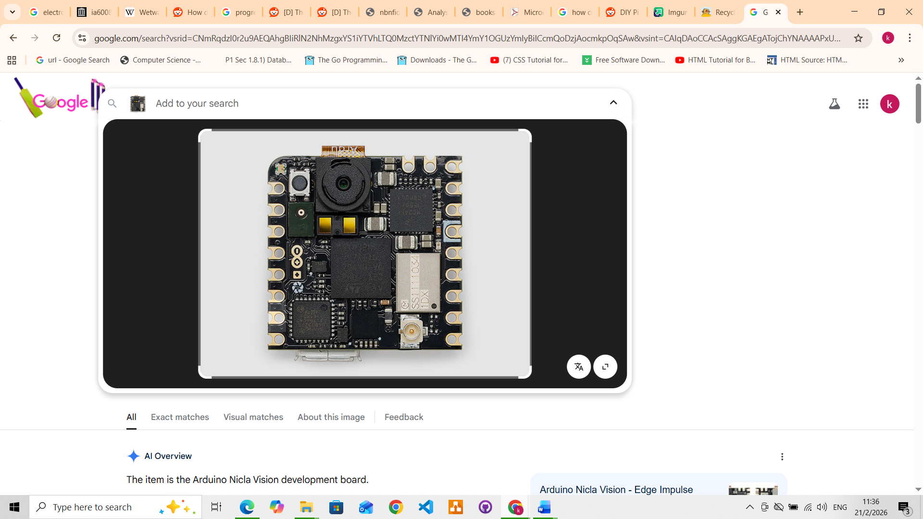
Figure 2.6: Arduino Nicla Vision

- Processor: STMicroelectronics STM32H747AII6 Dual Arm® Cortex® M7/M4
- Memory: 2MB Flash, 1MB RAM, 16MB QSPI Flash
- Camera: 2MP colour camera (supports TinyML/OpenMV)
- Sensors: 6-axis IMU (LSM6DSOX), Time-of-Flight (VL53L1CBV0FY/1), Microphone (MP34DT05)
- Connectivity: Wi-Fi / Bluetooth® Low Energy 4.2 (Murata 1DX)
- Security: NXP SE050C2 Crypto chip
- I/O: Castellated pins, I2C, SPI, ADC, 1.8-3.3V logic, high-speed USB (480Mbps)
- Power: 3.7V Li-Po connector
- Price: 90

STM32N6 Microcontroller
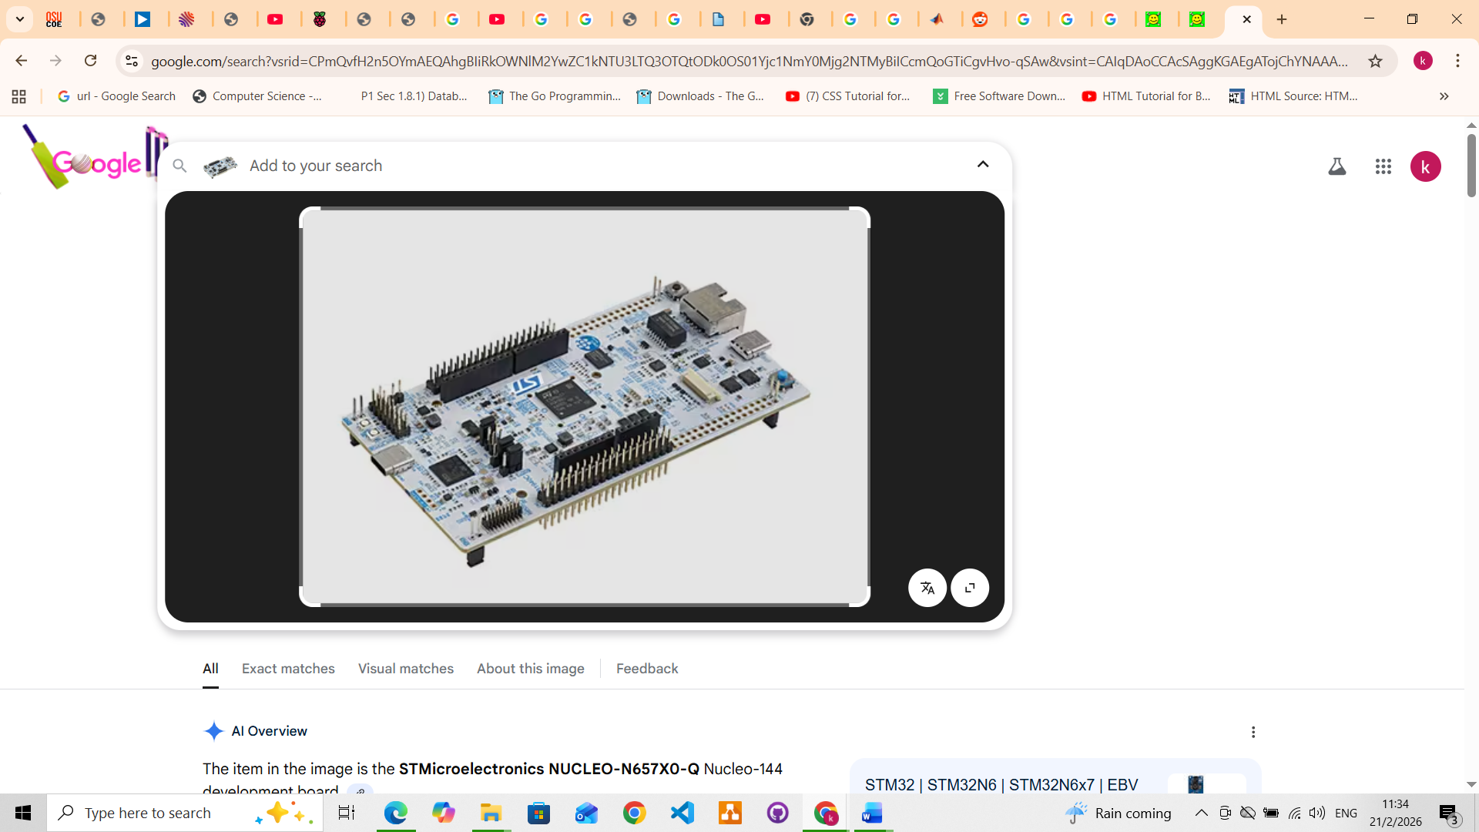
Figure2.7:STM32N6 Microcontroller

- Processor: Arm® Cortex®-M55 running at 800 MHz (highest frequency in the STM32 portfolio).
- AI Accelerator (NPU): Embedded "ST Neural-ART Accelerator" operating at 1 GHz, providing up to 600 GOPS (Giga Operations Per Second) for edge AI applications.
- DSP/Vector Processing: Uses Arm Helium™ (M-Profile Vector Extension - MVE) for advanced DSP and Machine Learning codes.
- Efficiency: ~3 TOPS/W.
- Performance Metrics: 1280 DMIPS
- Price: 21

2.3 Conclusion
Advancements in embedded research regarding developing and deploying machine learning models for farmers using transfer learning is advantageous approach in terms of compute and technical knowledge. Overall edge training and inference besides its use in agriculture can reduce data breaches, reduce latency speeds and enable reliability in various applications. The raspberry due to its versatility in terms of multipurpose system on chip architecture, price and availability is the best board for this project. Mobile Net due to their edge hardware specific architecture best fit the requirements of this project.
Despite these advances, three gaps remain unaddressed in the reviewed literature. First, the majority of edge-deployment studies evaluate inference performance only; the computational constraints of training a disease classifier directly on embedded hardware such as the Raspberry Pi 5 have not been empirically documented. Second, reviewed implementations provide classification outputs without spatial explanations; Grad-CAM visualisations that localise disease regions on the leaf image are absent from field-ready systems, limiting farmer trust and interpretability. Third, no reviewed work incorporates distribution shift detection to monitor model reliability after deployment; without a mechanism such as Population Stability Index (PSI) monitoring, models trained on laboratory datasets may degrade silently when exposed to real-world field images over time. This study addresses all three gaps.

CHAPTER 3: METHODOLOGY
3.1Introduction
Questions are what drive the process of finding out phenomenon using certain tools and procedures to come to conclusion using recorded results. Defining bottlenecks to making accurate predictions using neural network architectures such as CNNs on non-high performing hardware is one of the research directions of this chapter. The research also tries to understand neural network architecture weight adjustment using techniques such as gradient descent and how those weights are then used for making predictions on resource constrained hardware.
Materials
The materials used in this project included both software and hardware.
Component | Specification

Methods
Components Design and integration
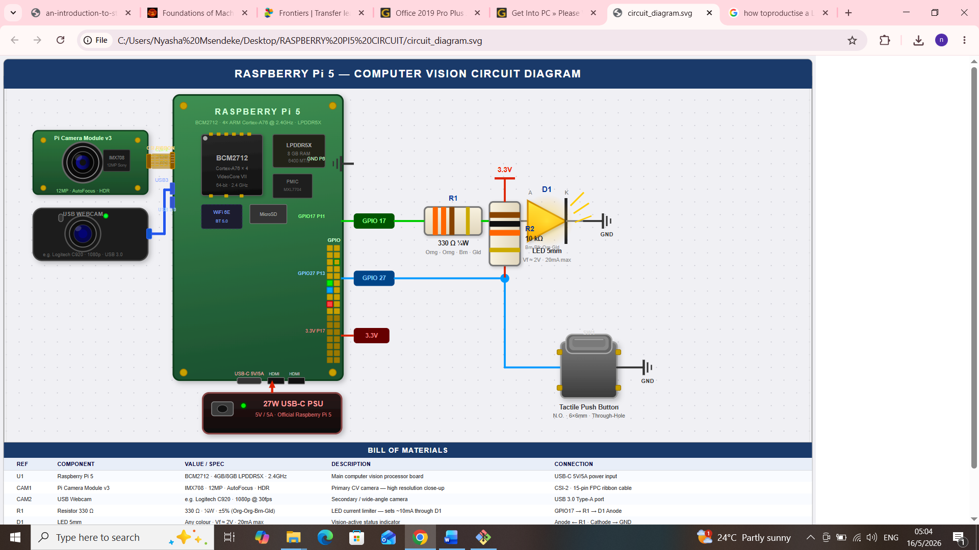
Hardware components were used to make the prototype according to the system circuit diagram shownr in Fig .

2.Software design and integration
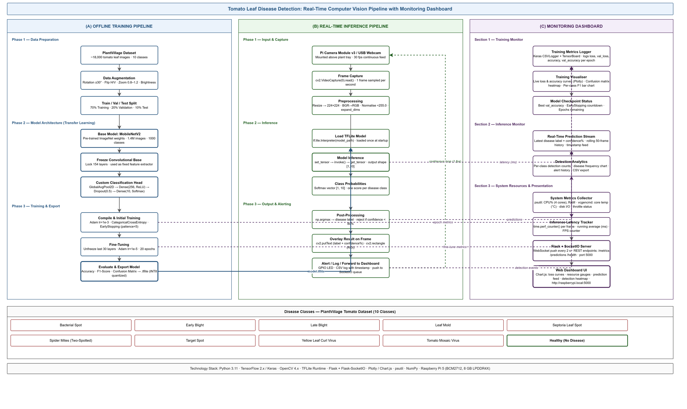
The software development was done according to the system architecture shown on the fig above. The software development life cycle used a development strategy known as for final system. is structured as a three-layer application:
- the ML pipeline (pipeline.py) encapsulates all data loading, model construction, training, evaluation, and inference logic;
- the user interface (components/main_ui.py) is a Streamlit web application exposing Inference, Training, and System monitoring tabs; and
- the system dashboard (components/system_dashboard.py) provides real-time hardware metrics and inference drift monitoring. This separation ensures the ML pipeline can be exercised independently via the CLI (main.py) without a running web server, which is important for reproducibility in batch evaluation.

2.1 Dataset details
The Plant Village dataset (Hughes and Salathe, 2015) was used as the primary image corpus. Plant Village contains laboratory-acquired leaf photographs across 38 plant disease categories. Ten tomato-specific classes were selected for this study, covering nine disease conditions and one healthy category (Table 3.1).
Table 3.1 — Disease classes and severity ratings used in Madomasi
Class | Display Name | Severity
Tomato___Bacterial_spot | Bacterial Spot | High
Tomato___Early_blight | Early Blight | Moderate
Tomato___Late_blight | Late Blight | Critical
Tomato___Leaf_Mold | Leaf Mold | Moderate
Tomato___Septoria_leaf_spot | Septoria Leaf Spot | Moderate
Tomato___Spider_mites ... | Spider Mites | High
Tomato___Target_Spot | Target Spot | Moderate
Tomato___Tomato_mosaic_virus | Mosaic Virus | High
Tomato___Tomato_Yellow_Leaf_Curl_Virus | Yellow Leaf Curl | Critical
Tomato___healthy | Healthy | —

2.1.2 Pre-processing and Splitting
Images were resized to 224 x 224 pixels to match the expected input dimensions of MobileNetV3Small. A stratified split partitioned the dataset into training (70%), validation (20%), and test (10%) subsets, using a fixed random seed of 42 for reproducibility.
Table 3.2 — Dataset partition sizes
Split | Images | Proportion
Train | 7,688 | 70%
Validation | 2,196 | 20%
Test | 1,100 | 10%
Total | 10,984 | 100%

Pixel values were normalized through the MobileNetV3-specific preprocess input function, which scales values to the range [-1, 1]. Normalization was fused into the model graph rather than applied as an offline transformation, ensuring consistent preprocessing at inference time regardless of input source.

3.4.2 Classification Head
The classification head was designed to be compact and regularized: the MobileNetV3Small backbone feeds into a GlobalAveragePooling2D layer, followed by a Dropout layer (rate = 0.3) for regularization, and a Dense output layer with 10 units and a SoftMax activation. Dropout at rate 0.3 was selected to reduce overfitting given that the training set is modest relative to ImageNet-scale datasets. Sparse categorical cross-entropy was used as the loss function, as class labels are provided as integers.
Dashboard
A monitoring dashboard was included within the software for monitoring hardware parameters as such as temperature, memory use and disk space usage to investigate the constraints under which computer vision models can be trained and made to use.
3.Fabrication and assembly
Overall system was put together making use of the hardware design and software design.
The training, inference was monitored by a dashboard which showed visualization of system functionality.
5.System Testing
During training this phase resource usage on Raspberry pi 5 was logged and monitored.
While during inference model performance on unseen data was taken account of.
Inference testing was also carried out using positive samples which were healthy tomato leaves. For these samples the system showed lower disease infection confidence as expected.

3.6 Evaluation Metrics
Model performance was assessed using:
- overall accuracy — the proportion of correctly classified test images;
- per-class precision, recall, and F1-score, computed via sklearn. metrics.classification_report, providing insight into class-specific performance that overall accuracy obscures;
- A 10x10 confusion matrix revealing systematic misclassification patterns between visually similar diseases; and (iv) macro-averaged F1-score — the arithmetic mean of per-class F1 scores, appropriate for a roughly balanced dataset.

3.7 Explainability — Grad-CAM
Gradient-weighted Class Activation Mapping (Grad-CAM; Selvaraju et al., 2017) was implemented to produce spatial heatmaps indicating which leaf regions drove each classification decision. Grad-CAM computes the gradient of the class score with respect to the final convolutional feature map and pools across channels. In the Keras 3 graph isolation model, the forward pass was split manually: the backbone and head are called sequentially inside a tf. Gradient Tape block, with the tape watching the intermediate feature-map tensor. The resulting heatmap is bilinearly up sampled to 224 x 224 and blended with the original image at a 55/45 ratio using OpenCV's JET colormap.
3.8 Out-of-Distribution Detection
An entropy-based out-of-distribution (OOD) guard was implemented at inference time. The predictive entropy H of the SoftMax output vector p is computed as H = -sum(p_i * ln(p_i)). Normalized entropy H-hat = H / ln(N), where N = 10 classes, ranges from 0 (perfectly certain) to 1 (uniform distribution). Inputs with H-hat >= 0.75 are flagged as likely non-leaf images and presented to the user with a warning. This threshold was chosen empirically based on the entropy distribution of held-out non-tomato images.

6. System deployment strategy
Model deployment was carried out in a tomato farming environment using
- Raspberry pi 5 running the full-precision. keras model directly with TensorFlow.
- Raspberry Pi 5 running an INT8-quantised TFLite model produced via tf.lite. TFLiteConverter with default optimization. INT8 quantization reduced model size and inference on the Pi 5's Cortex-A76 cores.

